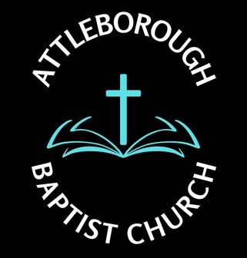 |  |  | Risk Assessment – Governance/Legislation
Location: Leys Lane, Attleborough NR17 2HX
Date: December 2024
Potential Hazard | Who is at risk? | Existing Control Measure | Risk Rating | Preventative Measures | Responsibilities
- Child Protection and Safeguarding  - Risk of Abuse of Children and vulnerable persons  - Sunday School |  | DBS checking  No working alone with children in the arranged activities  Persons attending level 2 and level3 safeguarding course | Med | - Interviews of persons who do not undergo DBS | - Deacons  - Safeguarding Officers
- Asbestos  - Risk of inhalation of particles | All who enter the building | Asbestos Survey 28th September 2016 by AES | High | - Removal of any asbestos as per regulation | - Deacons
- All Electrical Appliances  - Faulty appliances risk of electrocution  - Risk of fire | All who use the appliances | Portable Electrical Appliance Test  (PAT)  All appliances visual check before use any fault must be reported | High | - Remove and dispose of any faulty appliances  - Replace or repair if required | - Deacons

