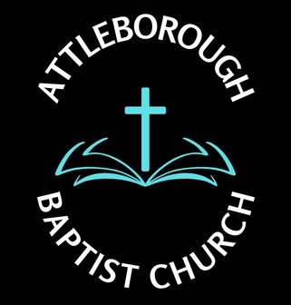 |  |  | Risk Assessment – Lighting/Heating
Location: Leys Lane, Attleborough NR17 2HX
Date: December 2024
Potential Hazard | Who is at risk? | Existing Control Measure | Risk Rating | Preventative Measures | Responsibilities
- Poor lighting or loss of lights  - Moving in the dark | People attending premises during dark hours | Adequate light provided with ability to change if circumstances dictate  Ceiling lights  Wall lights  Flood lights  Spot lights  Light bulbs and fluorescent tubes replaced as required | Low | - Power cut measures  - Torches to provide emergency lighting  - Storage of various lights and bulbs  - New batteries available for torches | - Deacons  - Fabric Officer
- Heating Equipment  - Too cold  - Too Hot | All attending premises particular older people | General heating provided by central heating radiators  Additional heating by convector heaters fixed above head height and portable oil filled radiators  Ceiling fan provide movement of air when hot | Low | - Boiler Maintenance on regular basis  - Heaters checked on a regular basis | - Deacons  - Fabric Officer
- Portable Electrical Appliances  - Electrocution  - Risk of fire  - Burns from hot surface | All attending premises | Turn off all electrical appliances if not in use  Ensure no material to come in contact with appliance | Med | - Inspect on regular basis to ensure function | - Deacon  - Nominated person

