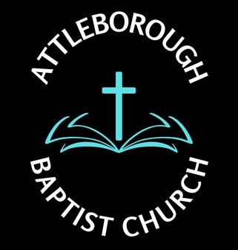 |  |  | Risk Assessment – Manual Handling/Food Hygiene
Location: Leys Lane, Attleborough NR17 2HX
Date: December 2024
Potential Hazard | Who is at risk? | Existing Control Measure | Risk Rating | Preventative Measures | Responsibilities
- Moving Chairs and tables | People moving furniture for meetings | Chair lift device provided  Familiarity of folding tables  Training given on request | Low | - Sign display advising people to use chair lift  - When moving tables request another person to help | - Deacons  - Volunteers
- Food Hygiene  - Sunday Morning tea and coffee  - Thursday Bible Group tea and coffee  - Tuesday Warm Welcome tea and coffee  - Women’s Group  - Alpha Group  - Special celebration meals  - Harvest Supper  - Easter  - Christmas  - Cakes for individual celebrations | People preparing food and those participating in celebration where food is provided | Kitchen offers two working areas  - Food Prep and cooking  - Washing up and cleaning  - Dishwasher provided  - Food hygiene certificates for individuals to supervise for premises food prep  - Aprons and gloves provided  - Fridge/freezer temps taken on Sundays and Tuesday | Med | - People preparing food  - Aware of food allergies and other dietary needs to provide satisfactory alternatives  - Food bought for specific events  - No food generally stored on premises | - Deacons  - Volunteers
- Portable Electrical Appliances  - Electrocution  - Risk of fire  - Burns from hot surface | All attending premises | Turn off all electrical appliances if not in use  Ensure no material to come in contact with appliance | Med | - Inspect on regular basis to ensure function | - Deacon  - Nominated person

