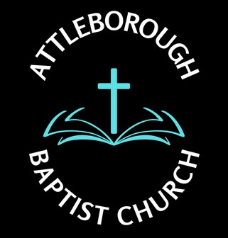 |  |  | Risk Assessment – Activities/Worship Service/Meetings
Location: Leys Lane, Attleborough NR17 2HX
Date: December 2024
Potential Hazard | Who is at risk? | Existing Control Measure | Risk Rating | Preventative Measures | Responsibilities
- Regular Sunday Services  - Risk of Trips or falls moving to and from seated area | Congregation 30 – 50 persons  Predominately older persons over 60 years old | Seating set out in rows and fixed together. Max 5 seats per row  Seating set up for 60 – 70 people with additional seating if required  Most attending will be regular and familiar with the room layout | Low | - Deacons to monitor changing need/situation  - Additional seating if required or high need due to desirability | - Deacons or nominated person
- Special Services  - Celebratory  - Christmas  - Easter  - Risk of trips and falls moving to and from seated area | Additional number in congregation  Some unfamiliar with surroundings | Providing usher to advise or seating and ensure individuals needs are met | Med | - Provide extra person to assist with needs  - Direction/special needs | - Deacon  - Usher or facilitator such as Funeral Director
- Deacons Meetings  - Members Meetings  - Trips and falls  - Expressed emotions/verbal attacks | Attendees | Appropriate measures meeting individual needs  Contain raised emotions/de-escalation | Low | - None | - Deacons  - Chairperson
- Sunday School  - Vulnerable persons  - Safeguarding Issues  - Possible falls  - Cuts  - ingestion | Children at risk | Person involved with Sunday School responsibilities to undergo DBS | Med | - Nominated persons only to be involved | - Deacons  - Sunday School person  - Parents aware
- Bible study and prayer meeting  - Vulnerable emotions | Small intermate group of mixed abilities and gender | Nominated facilitator to co-ordinate the group to ensure that needs are being met  Time, start and finish to be announced | Low | - Nominated persons only to be involved | - Nominated Facilitator
- Warm Welcome/women’s Group/Bible study/Alpha Group  - Trips and falls  - Scolds from hot water  - Choking from food ingestion | Persons attending the premises  Volunteer kitchen staff | Monitor food provided with knowledge of ingredients  Boiling water from kettle will be used | med | - Food Hygiene awareness  - Food safety notice in kitchen area | - Deacons  - Nominated person  - Competent persons

